**Dynon Certified SkyView HDX STC Information**

This folder contains information needed to complete and certify as airworthy the installation of Dynon Certified products into a type certificated aircraft identified by make, model and serial number in the AML. Note that some of these documents - per the STC - must be maintained as part of the permanent records for the modified aircraft.

Copies of the STC and the current Approved Model List are available from the [FAA Supplemental Type Certificates](http://rgl.faa.gov/Regulatory_and_Guidance_Library/rgSTC.nsf/MainFrame?OpenFrameSet) site. Search for STC number SA02594SE.

In addition to the documents in this folder, customers installing the Dynon SkyView HDX STC in their aircraft need authorization from Dynon to use the STC. Such authorization is furnished by Dynon Avionics to the installing party as part of an authorized Dynon STC equipment purchase.

**SkyView HDX System Related Documents:**

**General Documents:**

* **103261-000 - SkyView HDX System General Installation Manual**

Provides general installation instructions applicable to any airplane.

* **103488-000 - SkyView HDX System Wiring Diagram**

Provides wiring schematics corresponding with SkyView HDX System Installation Manual

* **103777-000 - SkyView HDX System Equipment Installation Record**

Provides a means for installers to record the locations of installed equipment, along with the part and serial numbers of the installed equipment for future reference.

* **103221-000 - SkyView HDX System Maintenance Manual**

Provides Part 23 Appendix A compliant instructions for continued airworthiness of the SkyView HDX System in accordance with CFR §23.1529.

* **103272-000 - SkyView HDX Airplane Flight Manual Supplement**

Provides §23.2620 compliant supplemental flight information related to the SkyView HDX System.

**Airplane Specific Documents:**

Airplane specific documents will be found in folders named for the airplane make and model they support. Airplane specific documents will accomplish specific airplane equipment installations such as autopilot servos.

**SkyView HDX Related Files:**

**Generic Files**

* **GENERIC SINGLE EMS 4 CYL DISPLAY.dfg**

This file generates a FAR compliant Bottom Bar and 50% page EMS display for four cylinder engines. Install the file according to the instructions found in ***103261-000 - SkyView HDX System General Installation Manual.***

The Bottom Bar will look like the following illustration:

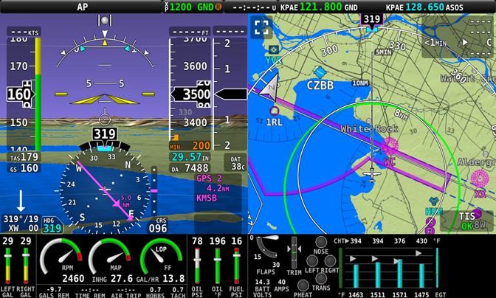

The 50% page display will look like the following illustration:

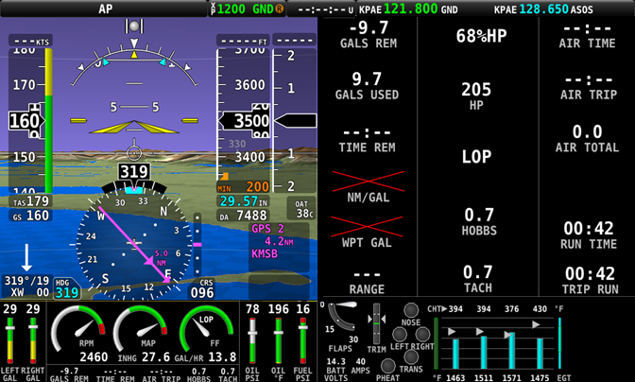

* **GENERIC SINGLE EMS 6 CYL DISPLAY.dfg**

Similar to above but for six cylinder engines. .

It is imperative that for these files to work correctly, that the system be wired in accordance with ***103488-000 - SkyView HDX System Wiring Diagram***. This file will configure the EMS Sensor Input Mapping information which establishes the assignment of EMS pins to functions. If your wiring is different, some editing of the EMS Sensor Input Mapping may be required.

Any functions or features added by these files not required for your airplane can be removed using the Screen Layout Editor.

**Airplane Specific Configuration Files**

Airplanes that have had autopilot installations developed by Dynon Avionics will have EMS display and Autopilot information saved into an airplane specific configuration file. These files will be saved in a folder dedicated to the specific airplane. Different airplane model variants may require different files. Read the file name carefully.